Grune 5th

## 

## Fish Baron Murdered

Fredrich Monger(41), colloquially known as the Fish Baron of Llamados, was yesterday found dead in an alley. The city watch are investigating but foul play is suspected. Mr Monger is 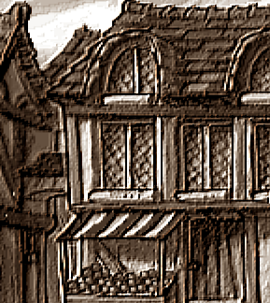survived by his wife Yvette Monger(56).

The Times is given to understand that Mr Monger was visiting the city on business when he was found dead in the alleyway connecting Snapcase Square and CockleCarrot Avenue on the morning of Grune 4th, just around the corner from his hotel.

*Alley behind the Parklane Hotel. Credit O. Crik*

1 Pence

Mr. Monger was believed to have no contract on him from the assassin’s guild and had purchased a year-long ticket from the thieves guild ruling out inhumation or a licensed robbery gone horribly ary, as such the watch are appealing for any witnesses in the area to come forward at Pseudopolis yard.

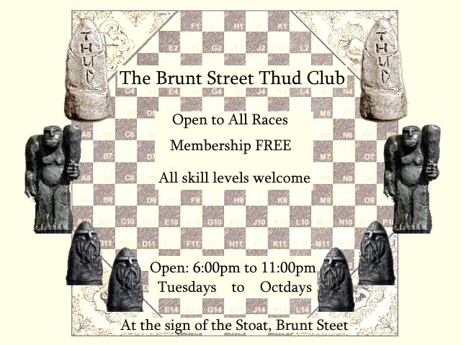

## Dwarf Ladies Club Protests Grags

On Grune 1st, The District Dwarf Ladies Club held a protest on Jubal Street against the continued presence of 2 dwarfish individuals. Grag Hamcleave(unknown) and Grag Docson(unknown) are 2 Grags that have recently taken up residence at number 4 Jubal Street where they purport to offer the services such as business consultation, arbitration and traditional funeral rites.

These Grags are divisive figures in the dwarf population of the city, as their knowledge of dwarf law and custom commands respect, but many members of the public see their views on certain practices as hateful and discriminatory.

The Dwarf Ladies Club explained that they were protesting the presence of the 2 Grags because of their views on openly female dwarf woman. The Grags have reported denounced openly female dwarfs as “*D'hrarak*” or none dwarfs, a view that, according to dwarfs interviewed by the times, is held as highly offensive.

Grags Hamcleave and Docson were unwilling to speak with The Times and could not be reached for comment.

# The Grave Digger Retires

Antony Cutaway(56), known by his barfighting name “The Grave Digger” has officially retired from professional bar brawling, having concluded his final brawl in the Mended Drum on Grune 1st.

Speaking to the Times, Mr Cutaway had this to say “Bar fights are a young man’s game and I’m getting on in years, I think it’s important that I walk away now before I have to be wheeled away. I’ll miss it but I don’t want to die for it.” Speaking about the introduction of choreographed fighting in the Drum Mr Cutaway said this “I know choreography upset a lot of purists when it was first introduced but I saw it as a chance at a safer work environment, but even with that and the presence of barside igors, you’re still ultimately putting your body on the line, you’re still taking bottles to the face, still taking stools to the back and still getting your arms sew back on. All those injuries mount up. ” 

Asked about what advice he would give to up and coming bar fighters, the legend advised “Have an exit plan. Bar fighting has a great entrance plan but no exit plan. You have to know what you’re gonna do once you leave the scene because you are gonna have to leave it, one way or the other.”

In concluding his interview, the Grave Digger wished to extend his thanks to all the fans that watched his brawls from under the tables at the Drum over the years.

## Watch Seizes 1000$AM in Slab

Yesterday the Ankh-Morpork City watch conducted a raid on the Hollow Statues Import Company resulting in the arrest of its owner Chalky The Troll(89) and the seizure of over 1000$AM worth of Slab, Slide, Slice and other assorted Troll drugs.

This seizure represents the single largest seizure of drugs by the City Watch this year. Seizures like these along with improvements in the treatment of addicts has led to a significant drop in Slab related deaths in the city in recent years.

The Watch wishes to ask any citizens suffering from Slab addiction to come forward and seek help from Sergeant Detritus' One Step Programme.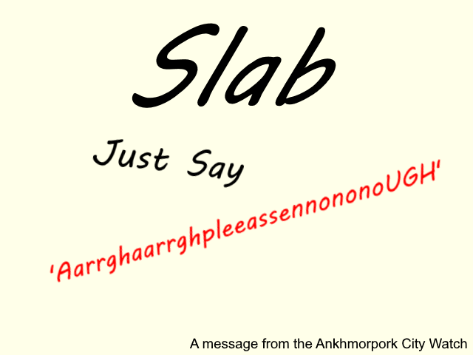



## Madam Aurilian’s the Gold Standard

Madam Aurialian’s Salon for the modern Dwarf Lady, found at the meeting of the Maul and Checker walk, is a up market salon geared towards female dwarfs, although unisex services are also on offer. Services include beard styling, hair styling, markup, dermatological treatments, jewel cleaning and armor polishing. Staff are courteous, friendly and accommodating. The Times has nothing bad to say about our experiences with Madam Aurialian’s. With plans by management for further expansion, Madam Aurialian’s looks primed to become a long standing part of the city’s fashion quarter.

## 